🔹 Assignment 1: Permanent Table
Goal: Test persistence, Time Travel & recovery
Tasks:
- Create a permanent table EMP_PERM
- Insert minimum 5 records
- Logout and login again
- Verify data persists
- Delete 2 records
- Query deleted data using Time Travel
- Restore deleted data
- Drop the table
- Recover using UNDROP TABLE
A Permanent Table is the default table type in Snowflake that stores data permanently until it is explicitly dropped.

- Create a permanent table EMP_PERM
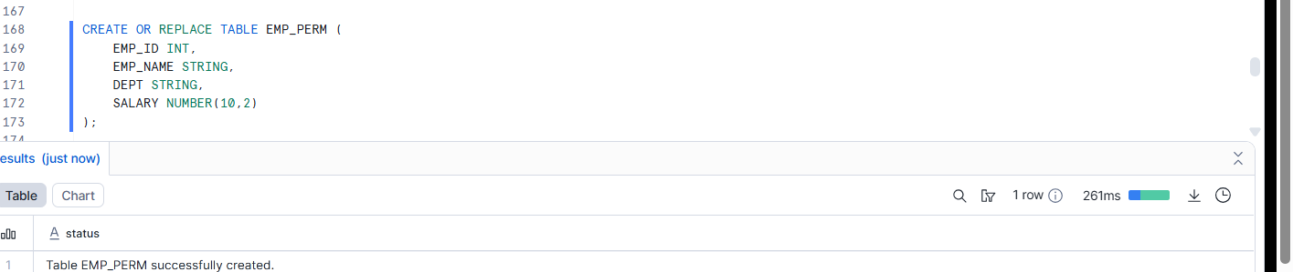
- Insert minimum 5 records

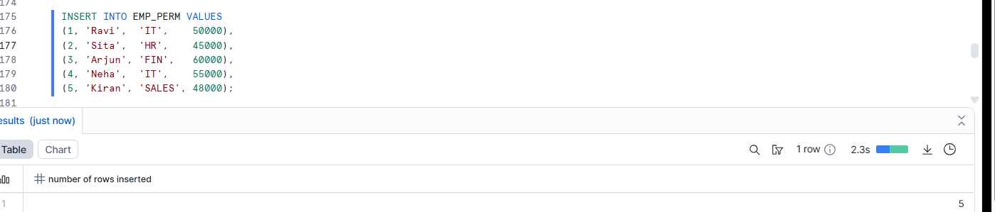
Logout and login again

4. Verify data persists
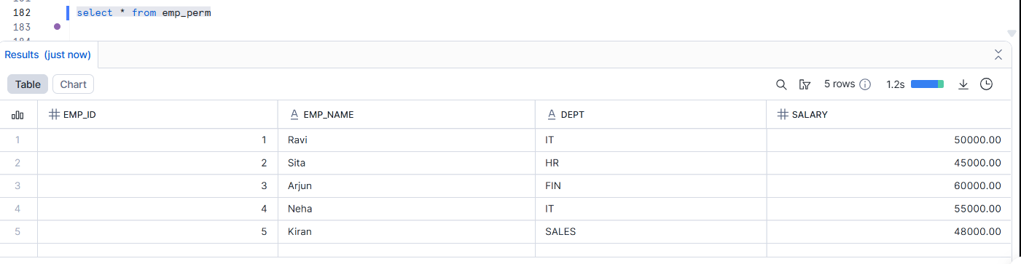
5. Delete 2 records
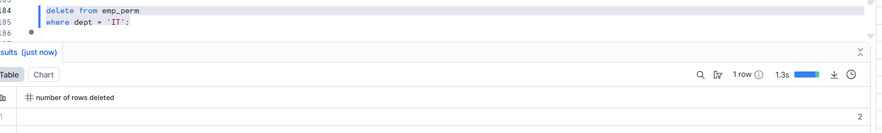
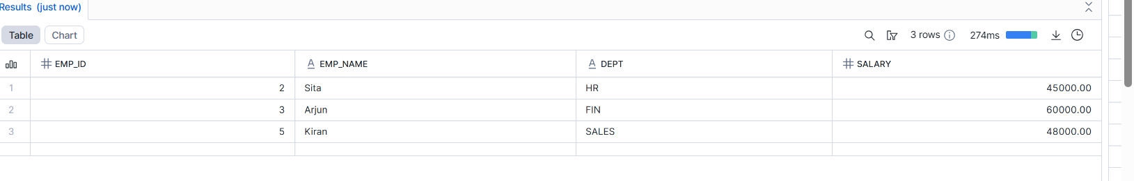
6. Query deleted data using Time Travel
After deleting records from a permanent table, you can query the previous version of the data using Time Travel.
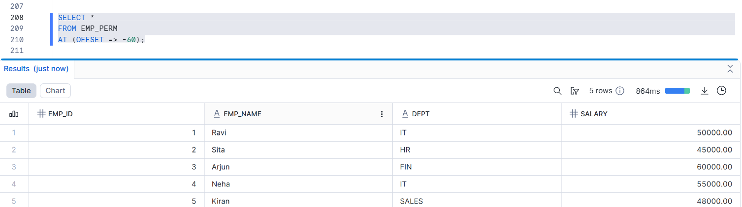
🔹 This returns the table data as it was 60 seconds ago, before the DELETE operation.

7. Restore deleted data
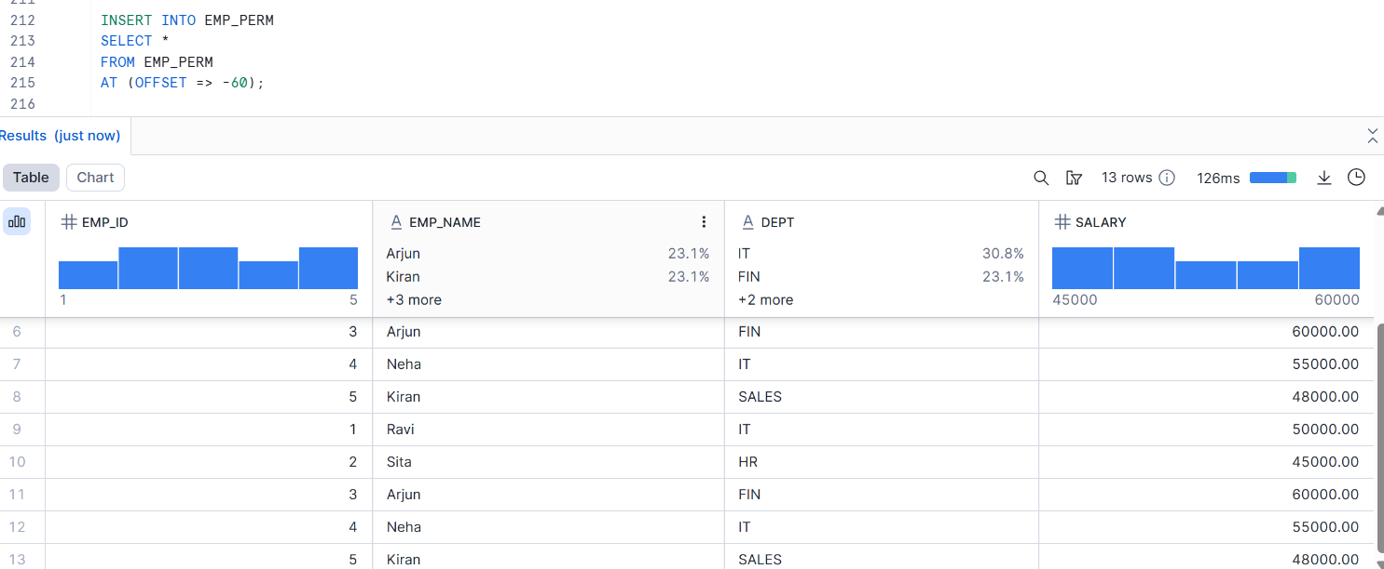
8. Drop the table
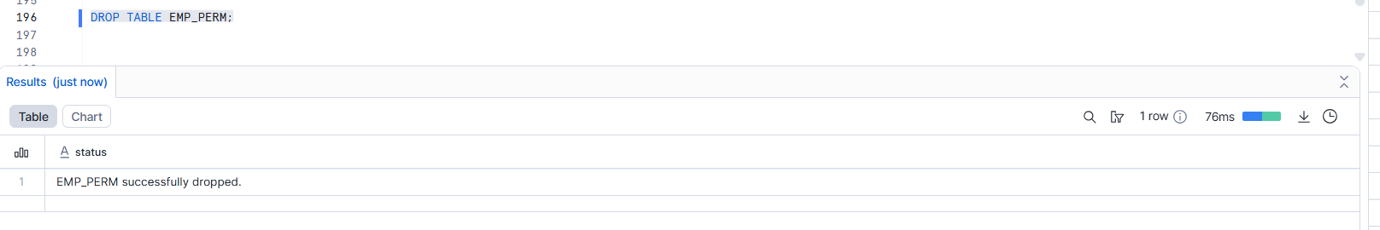
9. Recover using UNDROP TABLE
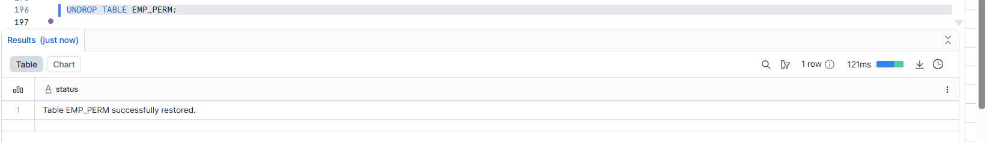

🔹 Assignment 2: Temporary Table
Goal: Test session-based background cleanup
Tasks:
- Create temporary table EMP_TEMP
- Insert records
- Query data successfully
- End the session
- Reconnect and query the table
Learning Outcome:
✔ Table automatically removed after session ends
✔ No Time Travel or Fail-safe
A Temporary Table is a table that exists only for the current session.Once the session ends (logout / worksheet closed temp also closed), the table is automatically dropped.

- Create temporary table EMP_TEMP
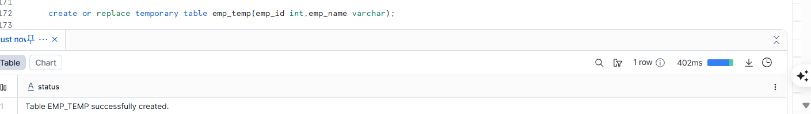
- Insert records
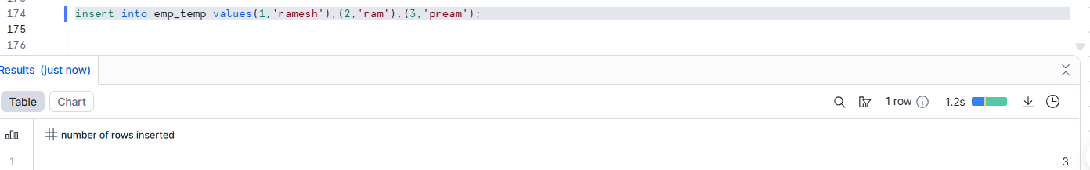
- Query data successfully
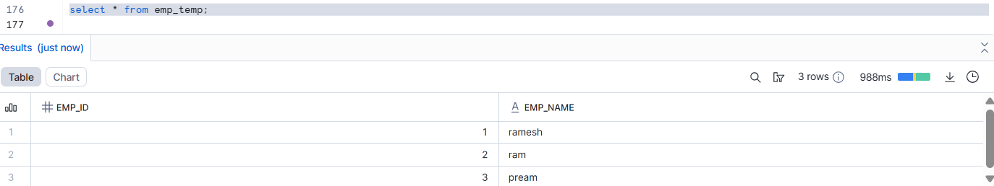
- End the session
Close the worksheet
Logout from Snowflake

- Reconnect and query the table
It will shown error.
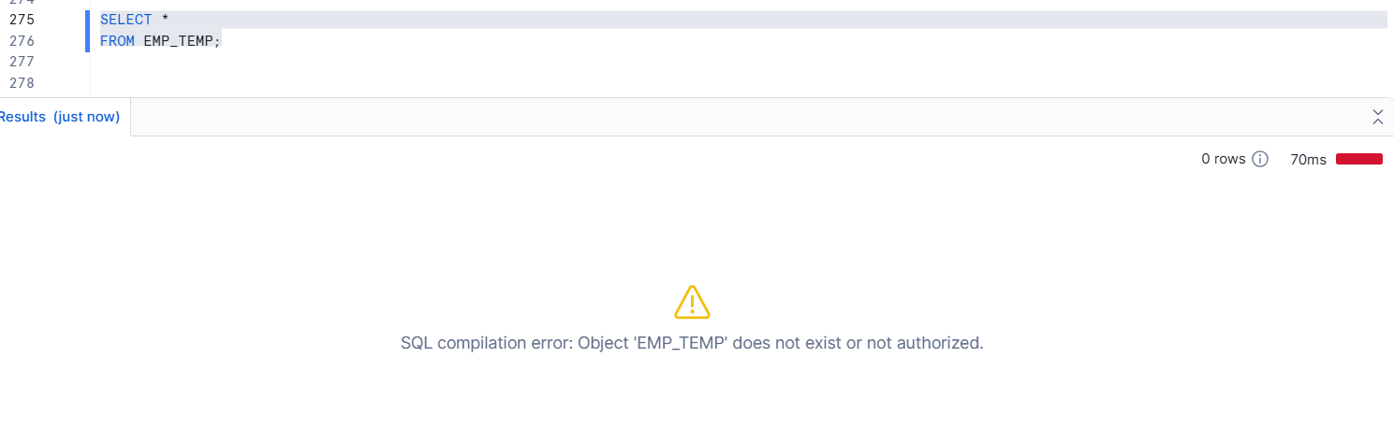

🔹 Assignment 3: Transient Table (low in cost compare to permanent)
Goal: Test limited retention behavior
Tasks:
- Create transient table EMP_TRANS
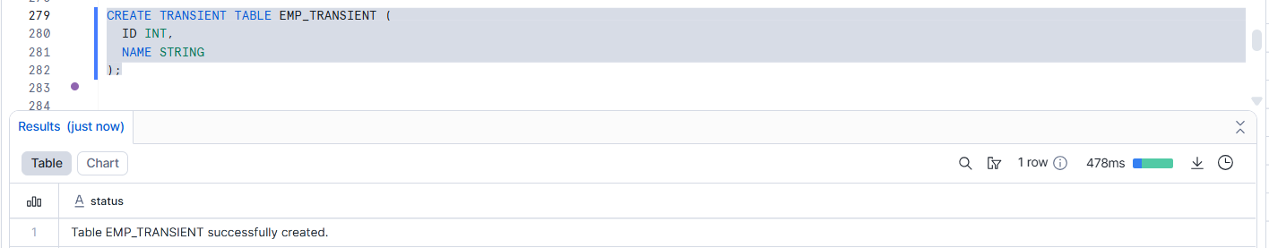
- Insert records
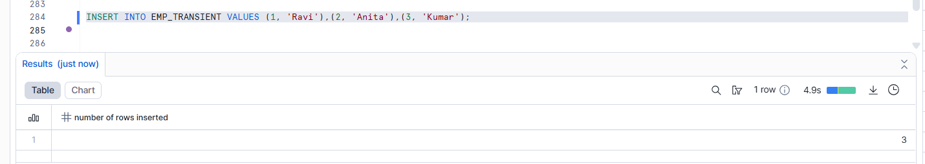
- Delete records
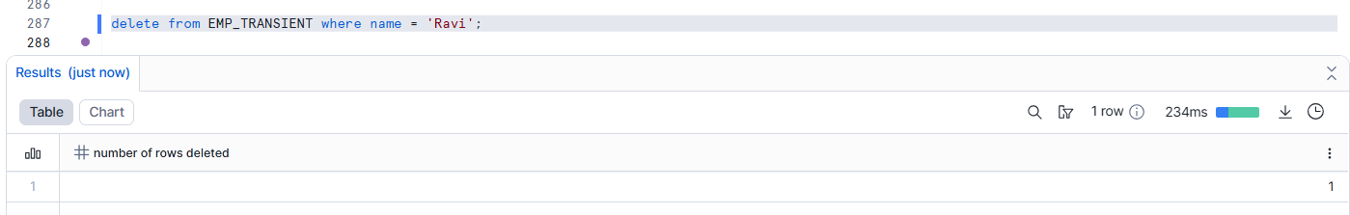

- Query data using Time Travel (within retention)
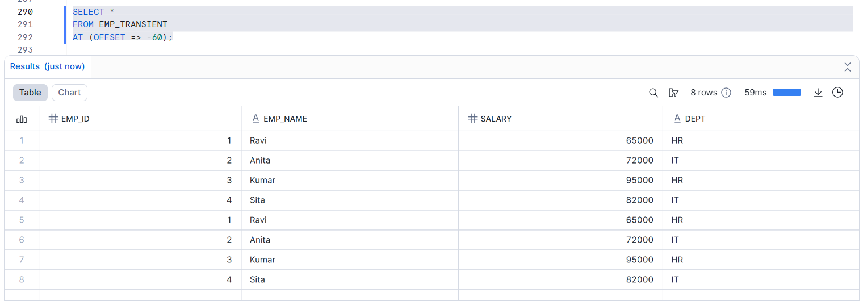
- Drop the table
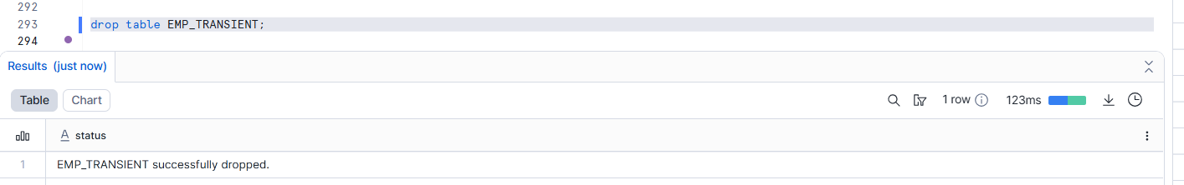
- Attempt recovery after retention period
Learning Outcome:
✔ Limited Time Travel
✔ No Fail-safe
✔ Faster background purge

🔹 Assignment 4: CTAS (Create Table As Select)
Goal: Test background data transformation
Tasks:
- Create table EMP_HIGH_SALARY using CTAS
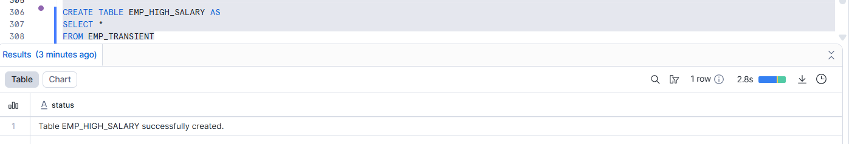

- Filter salary > 70,000
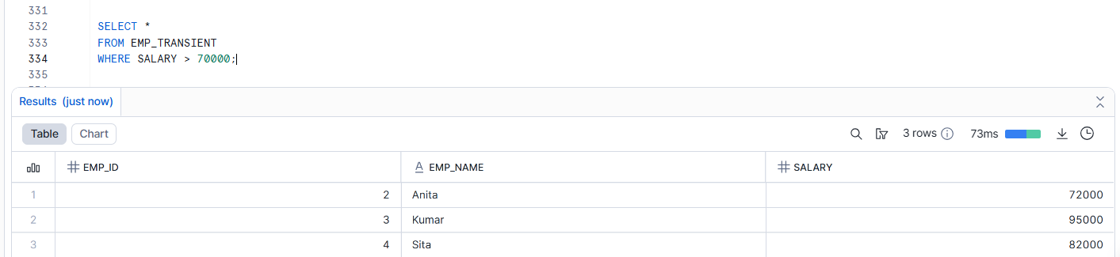

- Add calculated column SALARY_GRADE
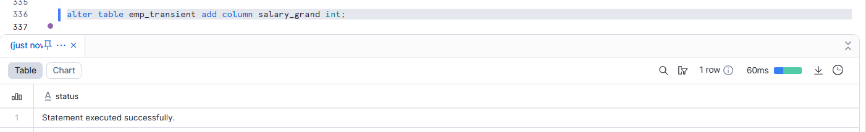
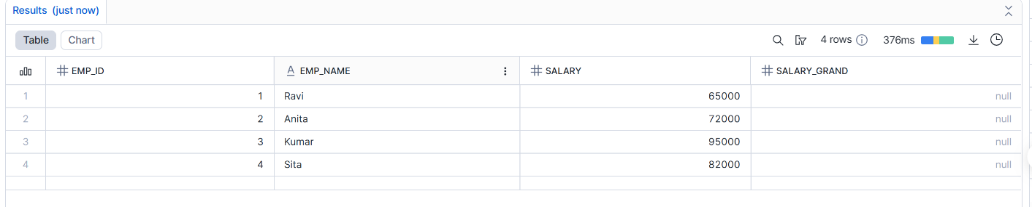
- Drop source table
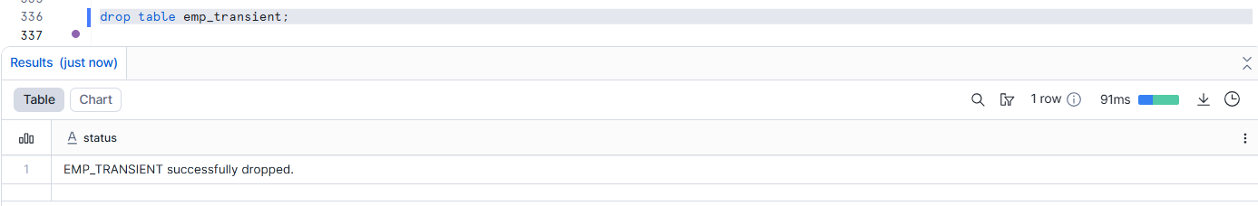
- Verify CTAS table still exists

Learning Outcome:
✔ Independent table creation
✔ Background transformation execution

CLONE = fast, shares storage
CTAS = slow, copies all data
🔹 Assignment 5: Table Cloning
when you clone a table / schema / database, Snowflake does NOT copy the actual data
Goal: Test zero-copy cloning
Tasks:
- Clone EMP_PERM as EMP_CLONE
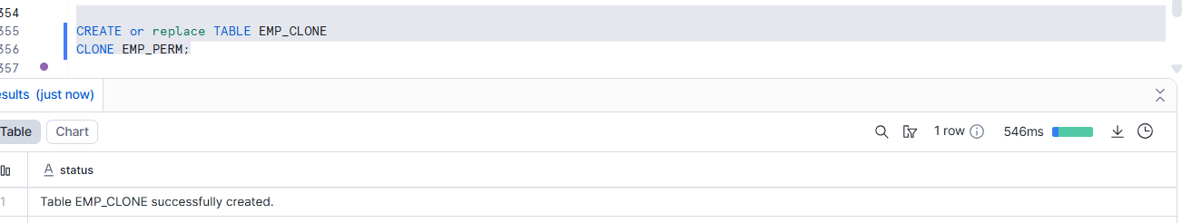
- Update data in cloned table
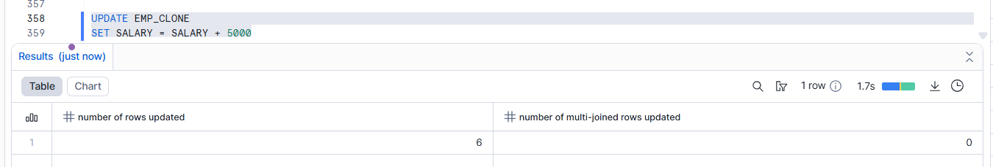
- Compare original vs clone
Select * from emp_clone….Select * from emp_perm;
…….This the original table in that IT = 50,000
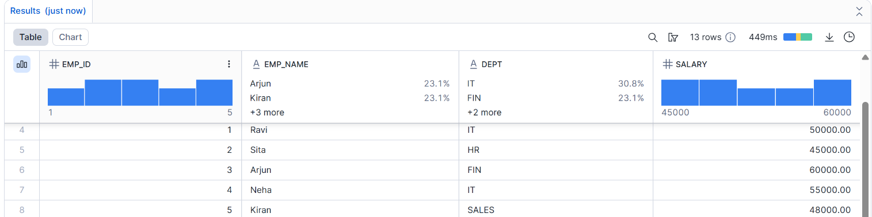

…….This is the clone table IT = 53,000
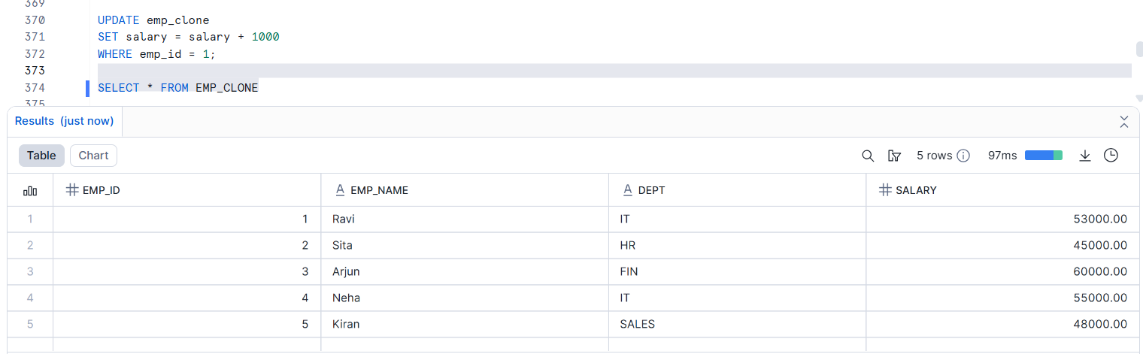

🔹 Assignment 6: Time Travel Testing
Goal: Test point-in-time recovery
Tasks:
- Perform DELETE on any table
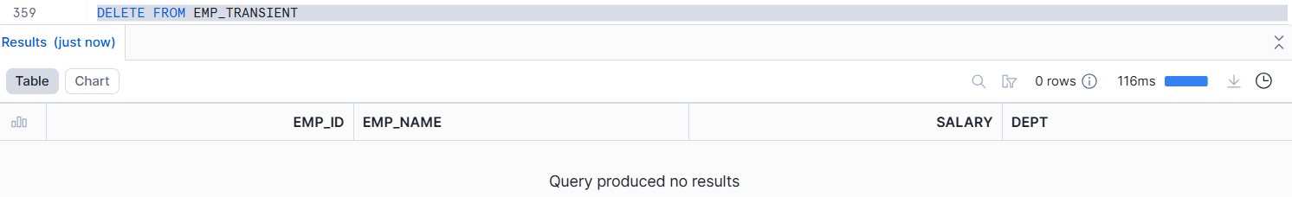
- Query using:
  - AT OFFSET
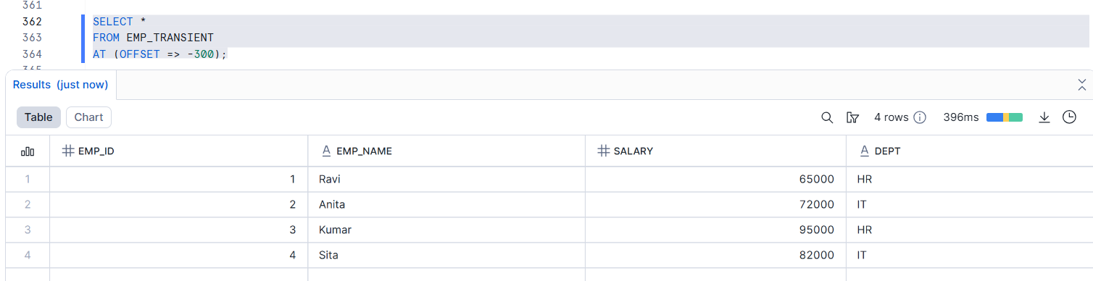
  - AT TIMESTAMP_Exactly when did it happen?
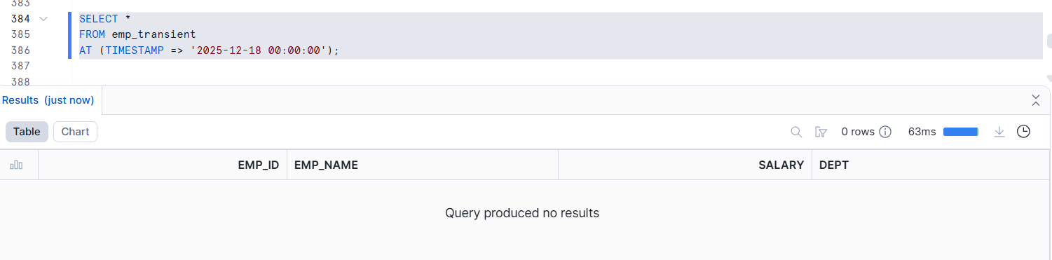
I changed the time:
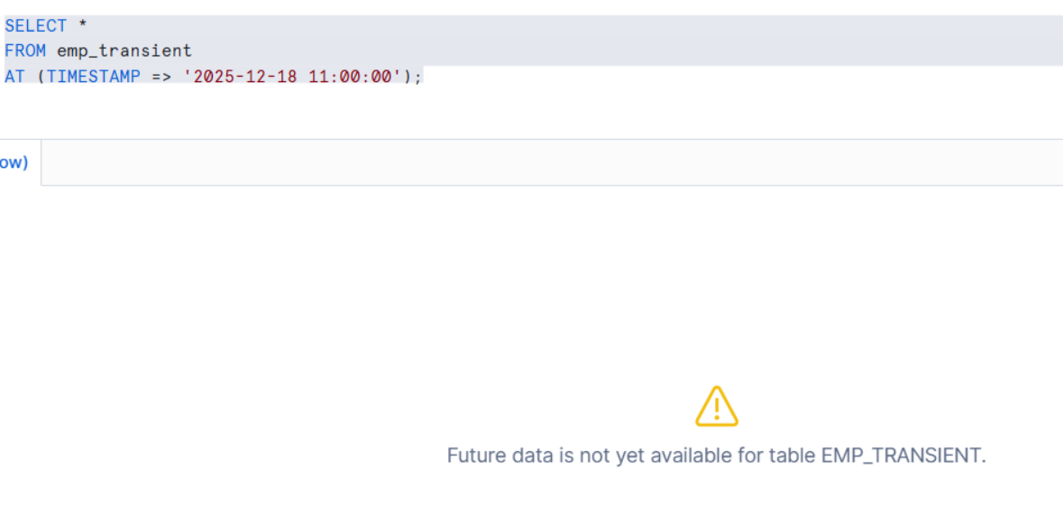

- Restore deleted data
Using OFFSET
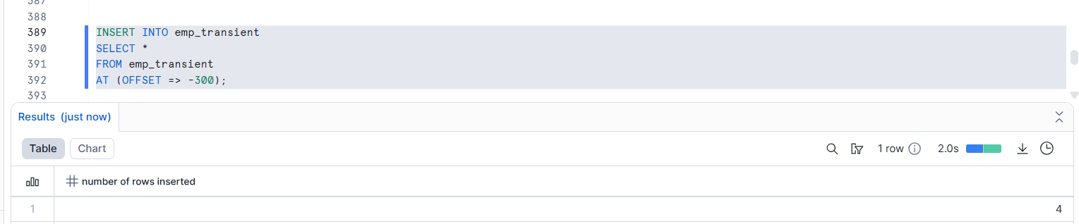

🔹 Assignment 7: Drop & Purge Behavior
Goal: Compare cleanup rules
Purge Behavior - deleted forever
Tasks:
- Drop Permanent table and recover it
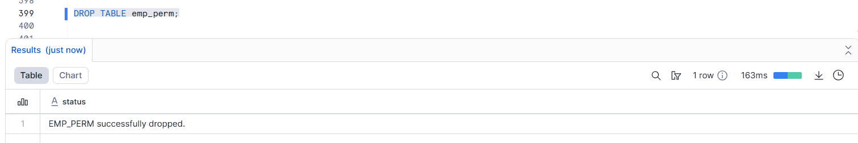
Recover it
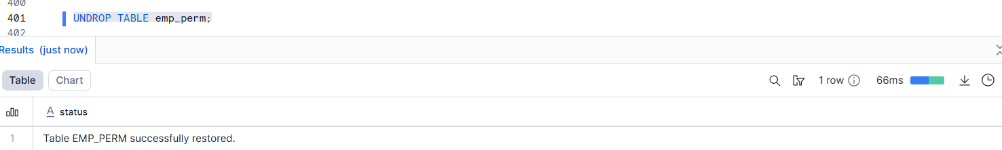
- Drop Transient table and attempt recovery
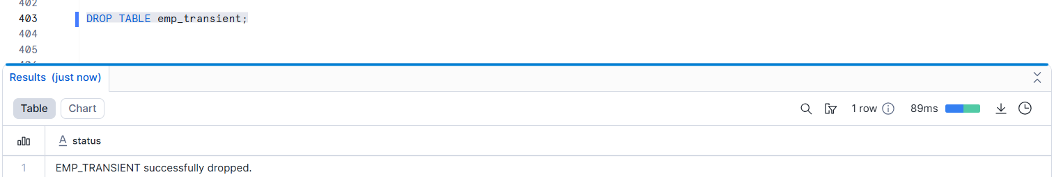
Attempt recovery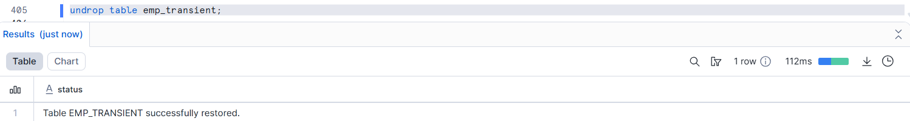
- Drop Temporary table and verify immediate removal
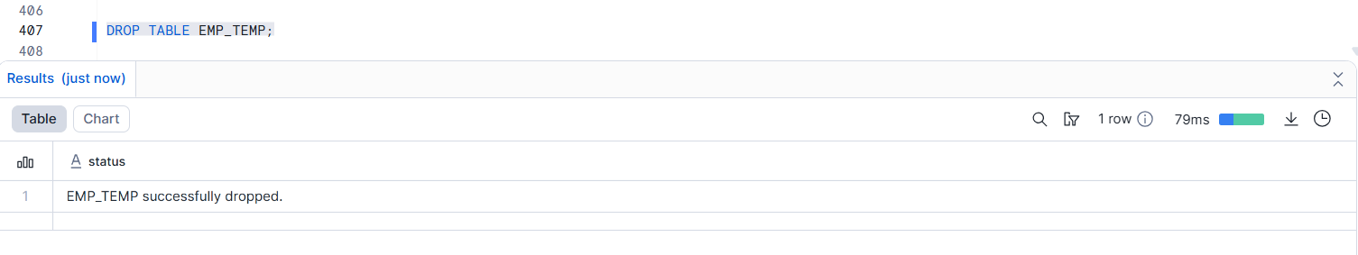
…..Verify immediate removal :
By using another session_id .it didn’t work.
Old session_id
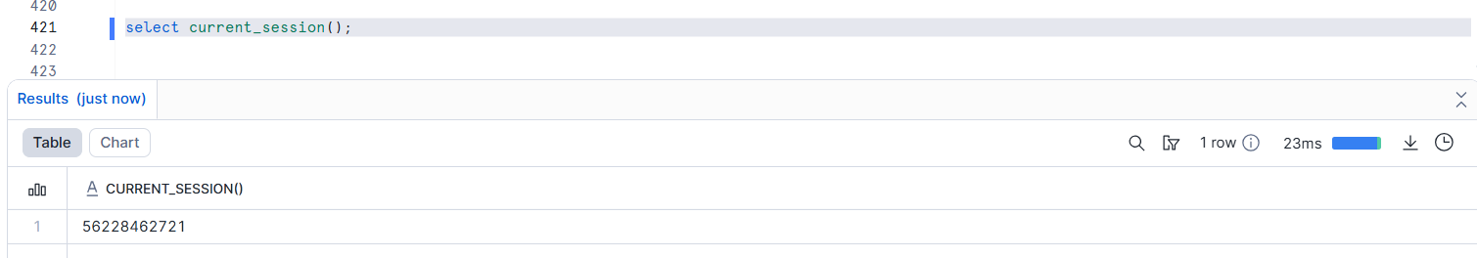
New session_id:
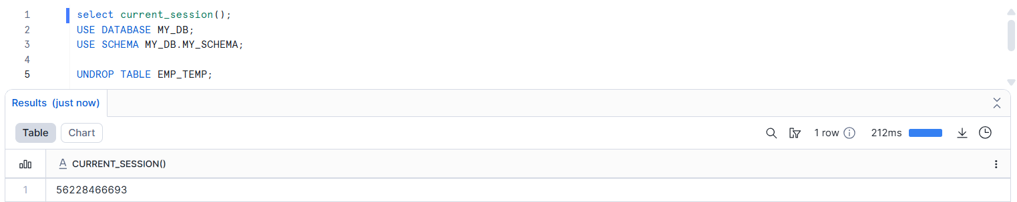
Final answer:
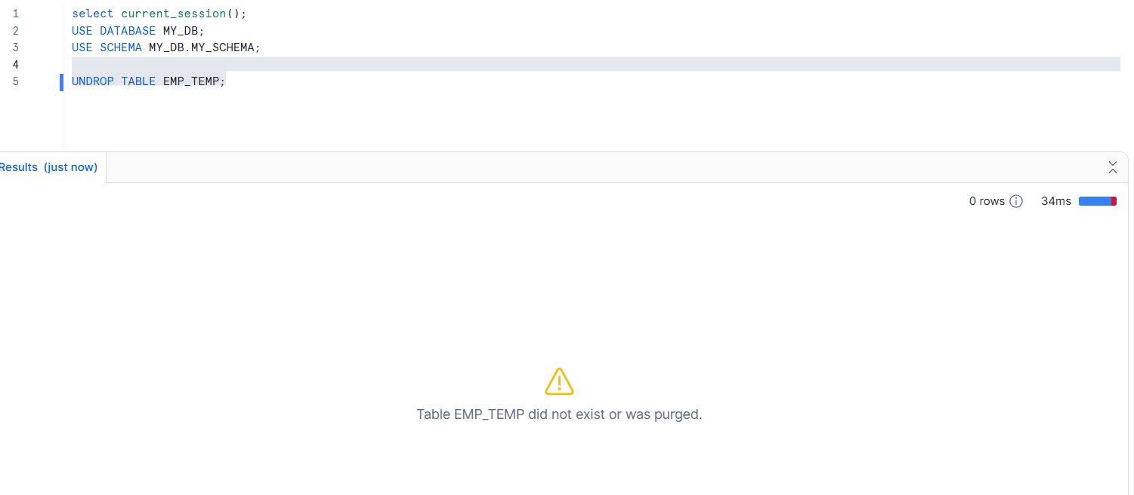
Assignment 9: Dynamic Tables
Goal: Test automated background refresh
A Dynamic Table is a table that automatically updates itself when the source data changes.
- Create a source table SALES_RAW
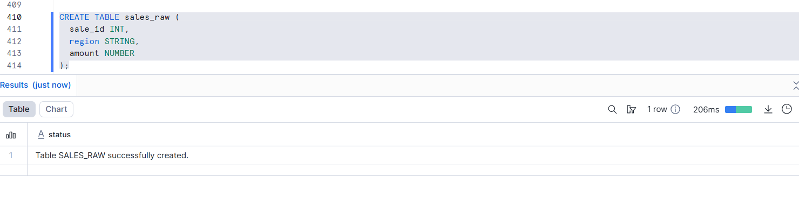
- Insert sample sales data
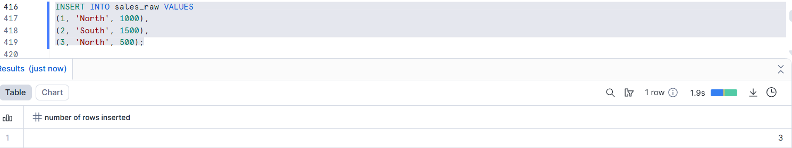

- Create a Dynamic Table SALES_AGG_DT
  - Aggregate total sales by region
Target_lag means how long the dynamic table can wait before updating.
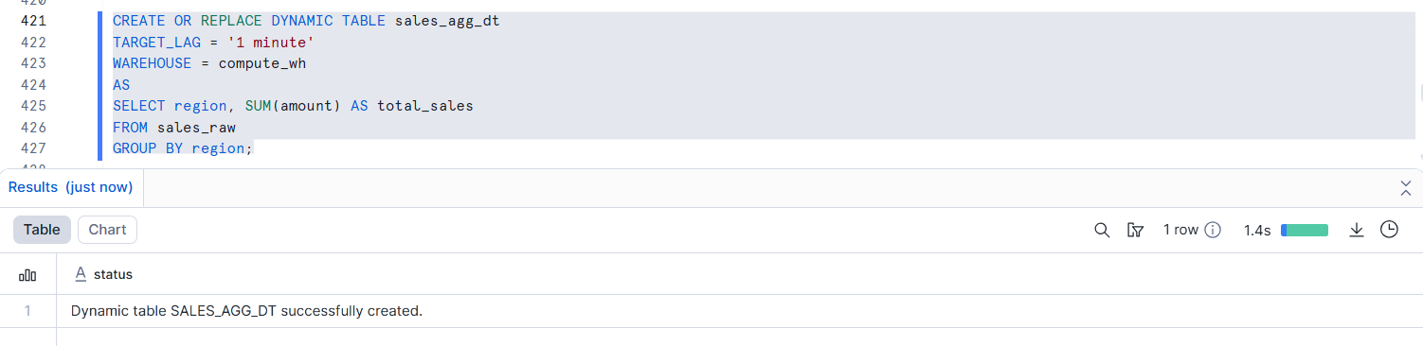

- Set refresh lag (e.g., 1 minute)
Refresh lag is the waiting time before updated data shows in a table.

- Insert new data into SALES_RAW
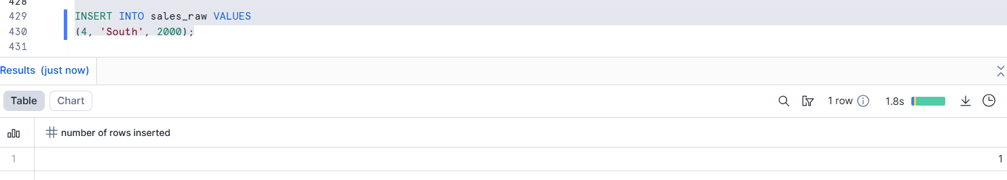

- Observe automatic refresh
